AP CSP Python with Robots  Mission 1 Assignment |  | Name:
Getting Started
Welcome to Firia Labs and programming with Python! To get started on your journey, open the CodeSpace programming environment and log in to your account.
Objectives
Complete Objective 1
Complete Objective 2
Complete Objective 3.
Click on the Debugging tool to add it to your toolbox. What is something you learned about debugging?

Scroll below the image and read about fixing bugs. Give a brief summary of the debugger.
Complete Objective 4. Click on the Camera Menu Help option. What kind of help is given?
Take the quiz. How did you do?
This Mission went over only a few parts of CodeSpace. Spend some time exploring the learning environment. Hover your mouse over the icons to see what each one is called and what it does.
When you are familiar with CodeSpace and all its parts, go to the “Check your understanding” on the next page.

Label the parts of CodeSpace:
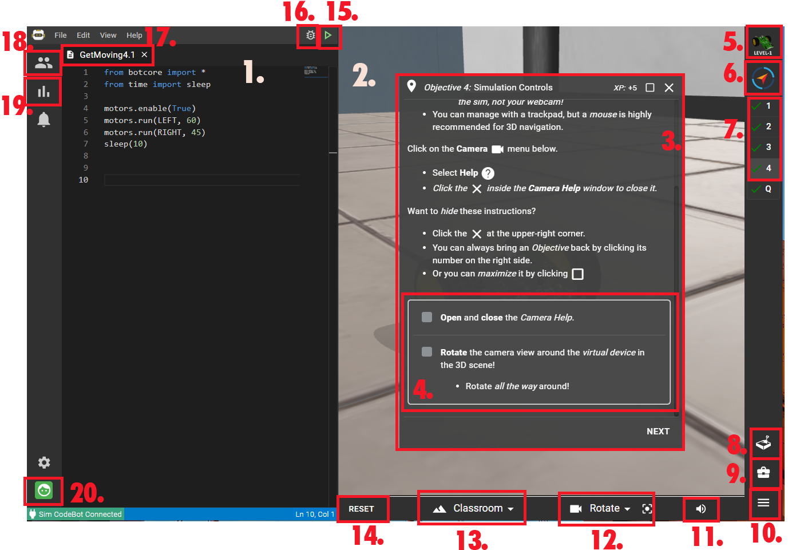
11.
12.
13.
14.
15.
16.
17.
18.
19.
20.

Parts of CodeSpace:
- Goals
- Objectives
- Camera controls
- Debugger
- Select Class
- Text Editor
- Log in / out
- 3D environment
- Filename
- Open console panel
- Reset the environment
- Current Mission Pack
- Run
- Objective panel
- Sandbox
- Progress and contests
- Toolbox
- Current Mission
- Select 3D environment
- Scene volume

